## Applied Dynamic Systems, Final Project

(Due Date for Presentation Link and Slides: Oct 21st; Q&A in Lecture: Oct 22nd)

## ( Total : 100 points )

## Possible Options for Final Projects

(The final grade will be based on the complexity of the system, modeling accuracy, depth in analysis, and performance in demo.)

1. Build a vertical suspension system as the example shown in class (with 2 masses and 2 springs. The 2 dampers can be neglected). Measure the key state variables trajectories (such as velocity, displacement) profile with respect to time with real-time sensors (velocity sensors, etc). Then model the dynamic system using Simulink. Compare and match the hardware measurement with the simulated dynamical results. (Suggestion: can use Arduino Nano for data collection and processing)

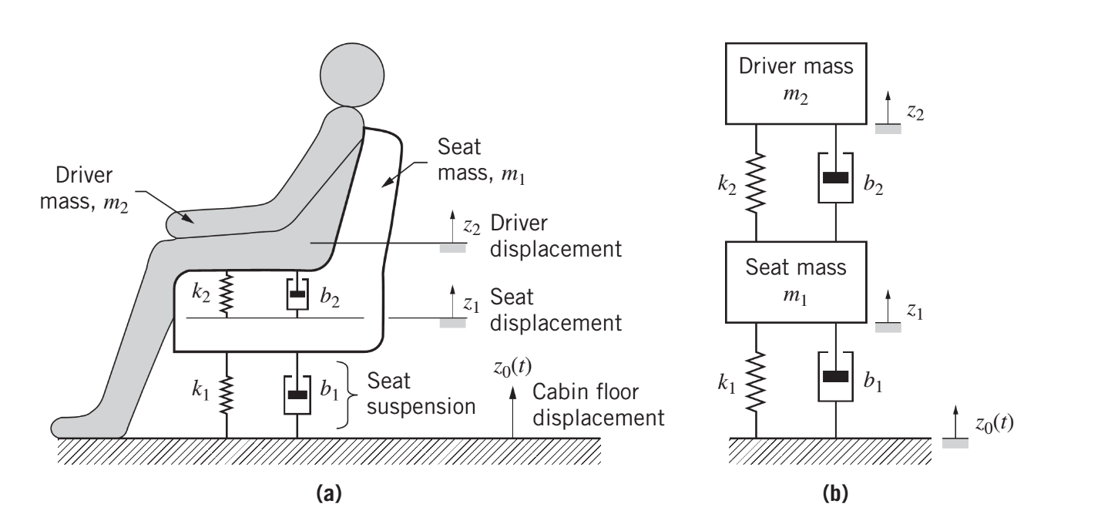

1. Build a solenoid actuator setup as the example shown in class as shown in Figure 1 below (with 1 solenoid actuator, driver and necessary velocity/voltage sensors). You can either build the solenoid actuator yourself or buy something off the shelf. Measure the key state variables trajectories (such as mass velocity, input voltage) profile with respect to time with real-time sensors (velocity sensors, etc). Then model the dynamic system using Simulink. Compare and match the hardware measurement with the simulated dynamical results. (Suggestion: can use Arduino Nano for data collection and processing)

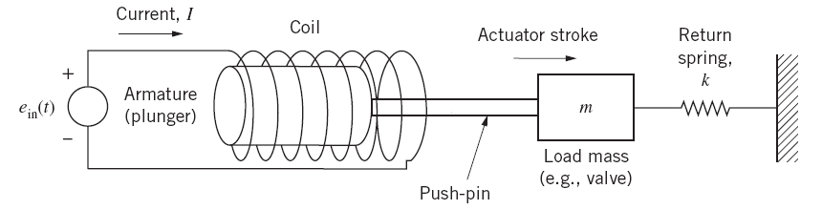

Figure 1. Solenoid Actuator

## Requirements:

1. A 3 mins presentation on a proposal of the selected subject should video captured and uploaded to Youtube. Submit the slides and Youtube link on Ecampus. Q&A in class.
2. The proposal should give the subject to work on, detailed plans, distribution of work among team members, timeline, and expected outcome at demo. ( 4 students a Team)
3. The proposal should also include a list hardware components to purchase. (Best from Amazon, Mouser or McMaster). You need to make sure the items can come in in short time, and you need to be responsible for choosing the proper vendor. The total budget should be less than $70. (Suggestion: can use Arduino for data collection and processing). Work with Rosanne to create a PO for parts purchase. (Instruction of creating the PO is attached).
4. Final project deliverables include a demo, a presentation, a lab manual and a final project report. The lab manual should follow the format of your current lab manual in class. You should prepare the lab manual assuming that the setup can be used for future class offerings.